Best Windshield Repair and Replacement Shop Near You in Amityville, NY
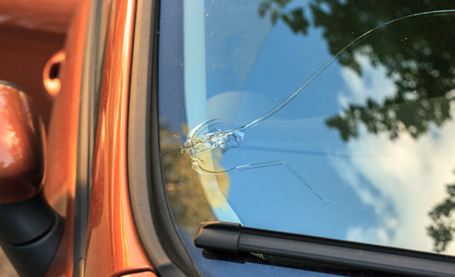
Amity Auto Glass is a family-owned business and has been providing windshield repair and replacement services across Long Island. There’s no need to spend time searching for the right shop if you already reached here. We offer all auto glass services including Windshield Repair near You, Windshield Replacement near you, Windshield Crack Repair, Car Windshield Repair and more. Our professionals will provide you with the best service in your area.
At Amity Auto Glass, we make auto glass replacement quick and easy. With over 60 years of experience in the auto glass repair and installation business, our technicians are professional and courteous. No matter what kind of car you drive, we will be able to fix your auto glass on the spot. We come right to you at home or work.
Windshield Repair near You
Did you know that many of the small cracks and chips that appear on windshields can be repaired instead of replaced? Amity Auto Glass services most vehicles in your parking lot, at your home or workplace, or even on the highway. Windshield repair is safe, effective, and convenient and typically takes Amity Auto Glass technicians less than 30 minutes to complete.
Amity Auto Glass has trained technicians to ensure quality auto glass repair and replacement at an affordable price. Our windshield repair specialists can restore your visibility while reducing the risk of further damage. They draw on knowledge of advanced technology to conduct in-depth evaluations and make informed suggestions.
Instead of replacement of your windshield, our process can repair chips, nicks and even cracks up to 3 inches long. It's fast and affordable, too ― in many cases, repaired windshields are eligible for insurance claims or a manufacturer's warranty. Let us help you decide whether repair or replacement is the best option for your car and get you on your way as soon as possible.
If you are looking for windshield repair near you then don't delay to contact Amity Auto Glass! Our staffs are here to help you with all of your auto glass needs.

